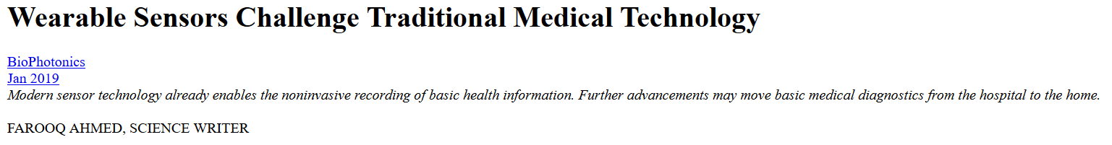
From Apple to Fitbit to Garmin to Google, in the U.S. alone, dozens of companies are producing wearable sensors that record our movements as well as basic health information. Many of these devices rely on optical telemetry to read information about the body and transmit it to a smartphone via Bluetooth or Wi-Fi. While the growth of the smartphone market may be leveling off — in part because users are keeping their devices longer — the wrist and body are still prime, underexplored territory.
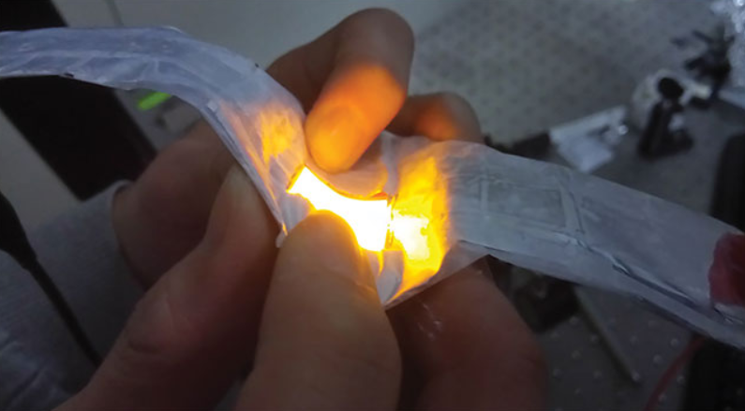
A flexible red organic LED made at the University of St Andrews as a wearable light source for medicine. Courtesy of Kou Yoshida.
PPG for the masses
The latest generation of Apple’s and Fitbit’s devices leverage a more than 50-year-old technique called photoplethysmography (PPG) to monitor heart rate. Typically, a pair of NIR or green LEDs illuminate the skin and underlying blood vessels, and a photodiode captures the reflected light to give a pulse signal for each heartbeat.
“Photoplethysmography and pulse oximetry are really interesting techniques that can be very low cost [and] simple, and [they] allow for continuous monitoring,” said John Allen, lead clinical scientist in the medical physics and clinical engineering department at Newcastle’s Freeman Hospital in North East England. Allen is also an honorary reader in vascular optics at Newcastle University and has been involved in PPG research for nearly three decades. “PPG is a composite measurement of the body’s micro- and macrocirculation,” he said.
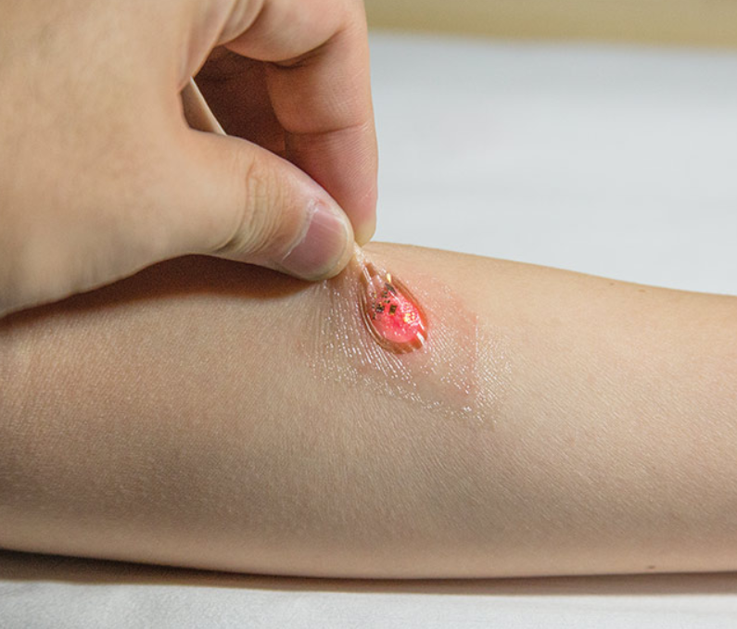
Ultrathin, skin-like optoelectronic systems capable of measuring photoplethysmograms and blood oxygenation in a battery-free manner through a wireless interface to a phone. Courtesy of John Rogers/Northwestern University.
But heart rate is just the beginning. Researchers and wearable device manufacturers are leveraging new designs, new fabrication techniques, and new materials to develop platform technologies that may transform our relationship with our bodies. They may also change our relationship with health care.
The Newcastle group is producing a portable system for doctors that uses PPG to detect potential arterial blockages within minutes in patients with peripheral arterial disease (PAD). By using multisite PPG to connect low-cost optical sensors to several places on the body, accessible diagnostics can detect PAD, Allen said. “This is important, as it is linked to increased heart attack and stroke risk.” Standard vascular tests in primary care, which include ankle-brachial pressure index readings, “can be challenging to do in this setting”¹.
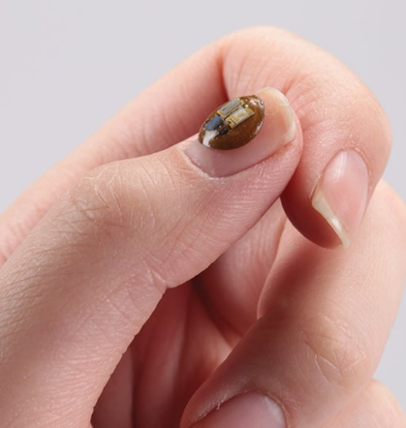
Millimeter-scale device capable of precise measurements of UV exposure in a battery-free accumulation mode of detection. Readout occurs wirelessly via an interface to a smartphone. Courtesy of John Rogers/Northwestern University.

Allen expects that, in the future, devices will need to be hassle-free as medical-grade products move out of the clinics and into homes. “Patients will have minimal training,” he said. “They will expect [the devices] to be automatic. This will lead to home diagnostics and medical wearable sensors not too dissimilar to the watch-based devices people already wear.”
Advancements in miniaturization and encasement and how sensors attach to the body should help decrease barriers to adoption of these devices.
Optoelectronic tattoos
While Allen’s PPG system utilizes commercially sourced optoelectronic components, Northwestern University (Evanston, Ill.) materials scientist John Rogers is pushing miniaturization, which he said is a relatively new direction for his group.
In the context of optical measurements as compared to electronic ones, Rogers said miniaturization provides a compelling direction for body-integrated devices, where “light-emitting and detecting components can be located on single platforms with millimeter-size dimensions.”
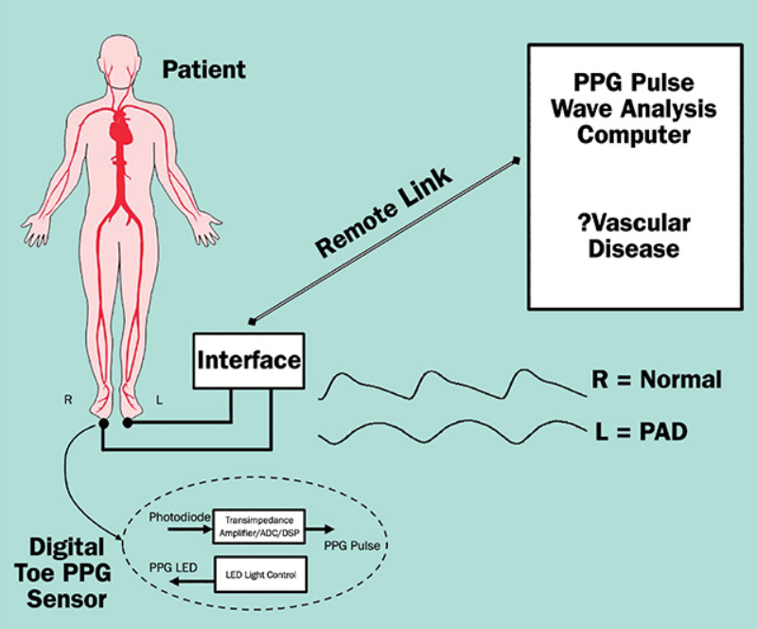
Freeman Hospital’s John Allen is building a multisite photoplethysmography (PPG) system that consists of wearable optical sensors to rapidly detect peripheral arterial disease. (PAD). ADC: analog-to-digital converter; DSP: digital signal processing. Courtesy of John Allen.
Rogers’ devices, which are essentially optical wearable sensors that mimic temporary tattoos, can be applied on the skin or fingernails. They incorporate well-established electronic and optoelectronic materials such as silicon, gallium arsenide, and gallium nitride. “It’s a hard/soft composite material structure that can integrate seamlessly with the body,” Rogers said. “That’s an important aspect in the design, because it allows us to leverage a lot of manufacturing approaches used in the consumer gadgetry industry.”
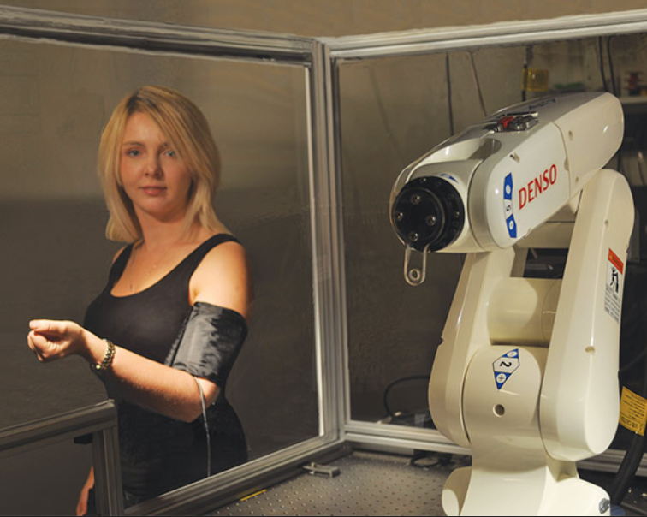
An early prototype of UCLA professor Aydogan Ozcan’s wearable microscope concept. Courtesy of Aydogan Ozcan.

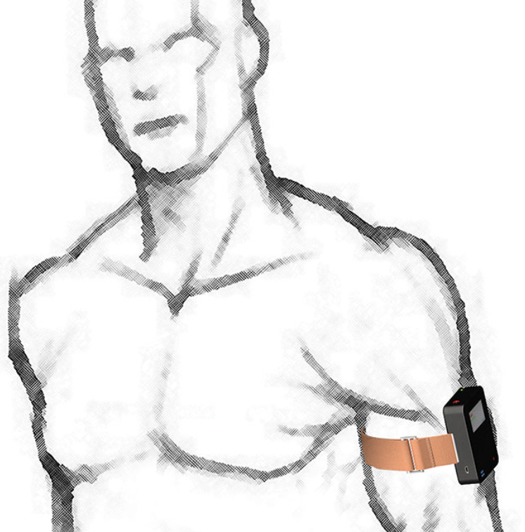
By attaching closely to the skin or on fingernails, the sensors mitigate motion artifacts. “This mounting location allows us to use strong adhesives, without irritation at the biotic/abiotic interface,” Rogers said. A fingernail-mounted sensor called UV Sense, which was created by his group for L’Oréal, measures UV exposure, and a phone app developed by the cosmetics company reveals the dosimetry to the wearer and uses geolocation to monitor relevant weather reports. The sensor and app were revealed at the 2018 Consumer Electronics Show in Las Vegas.
Light-emitting plastics
Sensors that conform to the body and enable continuous monitoring are “a big trend in medicine,” according to Ifor Samuel, a professor of condensed matter physics at the University of St Andrews in Scotland. His group uses solution-processing techniques to create and design organic semiconductors for flexible, wearable optoelectronic sensors.
“They are not like typical inorganic LEDs — point light sources. They are area light sources about 2 cm in diameter,” Samuel said. His plastic-based devices have been used to treat basal cell carcinoma through photodynamic therapy². “We find plastics everywhere in life for two main reasons: One is there’s a huge range of structures and hence of potential properties, and the other is they’re easy to shape. They can be flexible. They can be thin.”
Sketch of a wearable microscope. Courtesy of Aydogan Ozcan.

Samuel’s team has extended the use of light-emitting plastics to create a flexible optoelectronic tissue oxygenation sensor. “It’s proof of concept, but you could conceivably use such devices to measure neural activity [by looking at] local brain oxygenation,” he said.
In addition, the group attached pairs of its devices to a subject’s bicep. The system distinguished isometric and isotonic contractions as the subject moved her muscle to remotely control a robotic arm. “The difference in light scattering along the [muscle] fiber and perpendicular [to it] changes,” Samuel said. “So we get signals related to muscle contraction.”
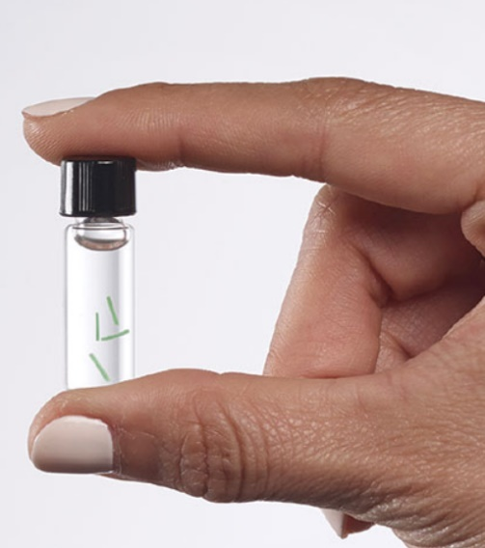
Profusa’s implantable biosensors can detect dissolved oxygen in the interstitial fluid surrounding a tissue. Courtesy of Profusa.
He predicts that organic, optical electronics will allow amputees to noninvasively control prosthetic limbs. “It’s quite impressive how much science fiction is coming true,” he said.
Because Samuel’s devices are unobtrusive, they can allow for continuous monitoring. The ability to monitor vital signs without interruption is one area where the next generation of wearables may help transform our relationship with the health care system. As Samuel points out, “Blood pressure can fluctuate day to day and hour to hour. Your physician may treat high blood pressure with medications, but unless you are regularly checking your blood pressure, you might still be at risk.”
Continuous monitoring of blood glucose, for example, has the potential to revolutionize diabetes management. “Everyone,” Samuel said, “would love to have a noninvasive glucose sensor.”
Glucose monitoring
Non- or minimally invasive glucose monitoring could free the nearly 25 percent of American adults with diabetes from having to draw blood to test their levels⁴.
Aydogan Ozcan’s group at the University of California, Los Angeles is one of several around the world developing such a sensor. In a National Science Foundation-funded project, they have teamed up with Texas A&M University, Rice University, and Florida International University to build a small subcutaneous implant that monitors the glucose concentration of interstitial fluid using light emission. According to Ozcan, a wearable optical reader containing a CMOS imager attaches to the skin and reads the implanted sensor.
“I think there’s a great need for [this system], especially for continuous monitoring of high-risk populations and patients with chronic conditions,” Ozcan said, noting that the implant would be injected 1 to 2 mm beneath the skin.
Optics “brings certain advantages,” he said, but an approach that marries electrochemical readings with optical ones “might truly turn out to be a preferred solution.”
His group is also developing wearable computational microscopes. They are lightweight, matchbox-sized devices that image large areas of the skin and can peer beneath to look for a variety of biological markers.
“It’s a generic platform,” Ozcan said, “but the Holy Grail is glucose monitoring.” The wearable microscope avoids artifacts such as tissue autofluorescence as it algorithmically subtracts noise from signal.
Oxygen monitoring
In October 2016, San Francisco-based Profusa Inc. received a CE marking that allowed it to market its Lumee Oxygen Platform in the European Union. The Lumee device works similarly to Ozcan’s implantable glucose system: A hydrogel-based biosensor, a few hundred microns in diameter, is injected with a hypodermic needle just beneath the skin, where it binds to dissolved oxygen in the interstitial fluid surrounding the tissue. A wearable reader sits on the skin, illuminates the sensor, records the reflected fluorescence, and provides a real-time reading of the oxygen level in the tissue.
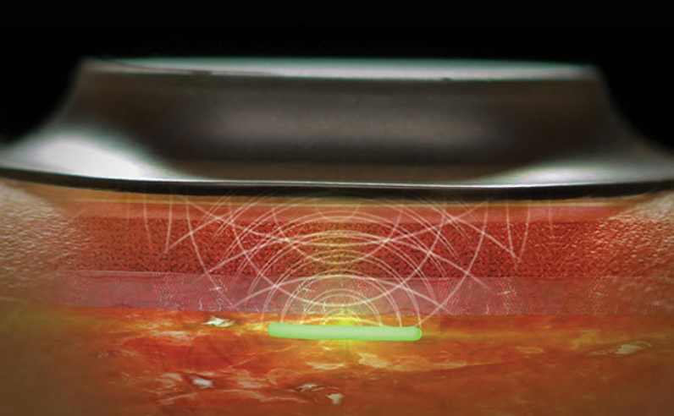
Illustration of Profusa’s optical wearable reader on the skin. Courtesy of Profusa.

According to Profusa CEO Ben Hwang, the biosensor is designed to evade the body’s reaction to foreign bodies. “It’s a major technological breakthrough for the industry,” he said, and it may allow the sensor to work in situ for years.
The biosensor acts as a signal transducer that translates levels of the biomarker of interest into light signals, while the wearable reader consists of low-powered LEDs, a photodetector, and an ambient light filter. In May 2018, Profusa published primary results of the Lumee system’s oxygen-monitoring capabilities as recorded in patients with chronic limb-threatening ischemia at St. Franziskus-Hospital in Münster, Germany⁵.
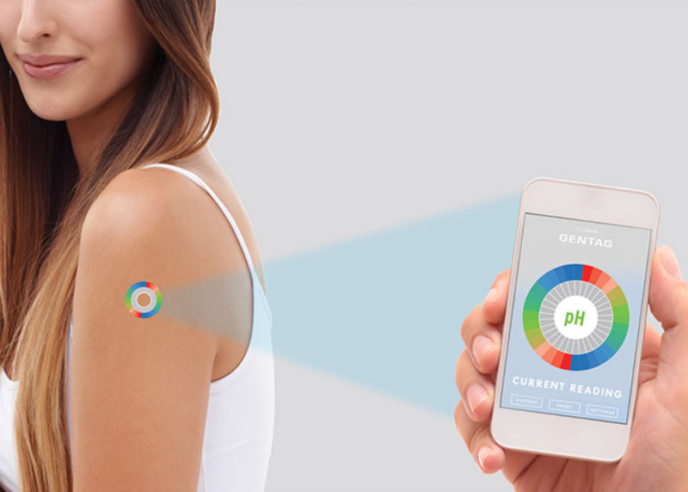
Gentag’s CEO, John Peeters, envisions new optical biomarkers that could be read directly by smartphones. (Image for illustration purposes only.) Courtesy of Gentag.

While Hwang is pursuing FDA approval for the Lumee in the U.S., oxygen monitoring is a first step. He envisions a multi-plex biosensor that can simultaneously measure oxygen, glucose, and lactate. “A physician might want to look at the overall metabolic health of an individual,” he said. “The intersection and interplay of [multiple] signal tracers gives you valuable data in real time.”
New optical biomarkers
Implantable biosensors combined with wearable optical readers seem poised to bring health care out of the clinic and into homes, delivering minimally invasive, continuous health monitoring for key biomarkers. However, John Peeters, CEO of Washington D.C.-based Gentag Inc., believes the technology won’t become transformative until new biochemistries coupled with new biomarkers emerge to take full advantage of noninvasive optical measurements.
“We are encouraged to see a very big emerging market for optical sensors,” Peeters said, adding that new chemistries create a broad array of tests at low cost. “A lot of current tests are just antiquated,” he said. Peeters anticipates the discovery of optical biomarkers that could be read directly by smartphone cameras, obviating the need for implantable biosensors and specialized wearable readers.
Gentag is building what Peeters calls “printable chemistries on substrates.” The sensors could be disposed of after a single use and crafted for specific medical applications. He said the company holds more than 100 patents that cover a broad base of sensor technology, and it has an agreement with the Minnesota-based Mayo Clinic to create wireless sensors for use in the treatment of obesity and diabetes.
Peeters does not think optical wearable sensors will ever replace clinical care, but they will allow for “robust triage technology.”
Changing health care
Newcastle’s Allen said he’s already seeing changes in hospital settings. “I’ve been in [a U.K.] National Health Service hospital for 30 years … and care is moving closer to home. With technology now, the target is for patients to come in for shorter times and be discharged much quicker.”
According to Allen, medical-grade wearables will also bring diagnostic information into communities. “Patients won’t necessarily have to go to hospitals for all of their tests,” he said, “and early detection — and therefore prevention — of diseases should benefit greatly.”
As the devices increase in acceptance, Profusa’s Hwang sees the lines between patient and nonpatient blurring, citing Type 2 diabetes as an example.
“One day, my doctor might test me and say, ‘You’re a diabetic now.’ But the truth is, I probably have been marching down the path for the last 20 years, and it’s just that I’ve tipped over the clinical definition,” he said. “By leveraging biosensors to monitor data continuously and in real time, prediabetic patients can more effectively partner with physicians to ensure they don’t get full-blown diabetes. The impact here could be enormous.”
With new optical wearable devices, Hwang said, “Our ambition is first to absolutely prove our clinical relevance in these verticals of disease state, [and then] pry the technology away from the walls of the hospital [and bring it] into people’s homes.”
www.linkedin.com/in/farooqtheahmed
Acknowledgments
The author would like to thank John Allen, Newcastle’s Freeman Hospital; John Rogers, Northwestern University; Ifor Samuel, University of St Andrews; Aydogan Ozcan, University of California, Los Angeles; Ben Hwang, Profusa; and John Peeters, Gentag.
References
1. M. Bentham et al. (2018). Innovative multi-site photoplethysmography analysis for quantifying pulse amplitude and timing variability characteristics in peripheral arterial disease. Diseases, Vol. 6, Issue 3, p. 81.
2. S.K. Attili et al. (2009). An open pilot study of ambulatory photodynamic therapy using a wearable low-irradiance organic light-emitting diode light source in the treatment of nonmelanoma skin cancer. Br J Dermatol, Vol. 161, Issue 1, pp. 170-173.
3. A. Bansal et al. (2015). Wearable organic optoelectronic sensors for medicine. Adv Mater, Vol. 27, Issue 46, pp. 7638-7644.
4. Centers for Disease Control and Prevention (July 2018). More than 100 million Americans have diabetes or prediabetes, https://www.cdc.gov/media/releases/2017/p0718-diabetes-report.html.
5. M. Montero-Baker et al. (May 2018). Potential utility of tissue oxygen sensors in perfusion monitoring. Endovascular Today, https://evtoday.com/2018/05/potential-utility-of-tissue-oxygen-sensors-in-perfusion-monitoring.

