LOGIN IN TO “MINDFLASH” TO MONITOR STUDENT STATUS,
TIMES, AND DOWNLOAD CERTIFICATE COPIES
Professional Medical Education Assn
The Laser Training Institute
Feb 2023
This is for the group coordinators that we work with for laser training for your own personnel /students. We have given you “reporter” status in the Mindflash system so that you can log in and check on the status of any of your enrolled students. You can see their progress through individual course modules, see their quiz scores on modules, and see when they’ve completed a course. Once they have completed it you (and they separately) can download a copy of the Course Certificate. A short time after they have completed their course they are “archived” in our system so they can’t access it again. However, with reporter status you can log in and view their archived file and re-download certificates if you need. You can also run off copies of reports on your group showing all their status and progress. There are export links in those windows, and you can download them as csv or excel files. You will remain active as a “Reporter” as long as you continue to be the contact person with Professional Medical Education Association. When you are no longer a contact you will not have further access to the system.
You will not be able to change anything while you’re in the program, including reactivating them from archive status. Some of those menu commands are there for you, but if you try to use them, you’ll get some sort of “DO NOT HAVE PERMISSION” reading and it won’t let you complete. You will also only be able to access your own group – not any others.
We’ll show you some screenshot clips here to get you started with viewing this information, but it really comes down to logging in yourself and experimenting to see the choices you have and various windows for student information. This document will summarize the important points, but there is much more available to you once in the program.
If you need to verify someone’s training time or scores for some type of credentialing agency, you can do these reports or screen clips, or you can give them your “reporter” username and password to let them access it directly. Making copies is easier so you don’t have to teach them.
Any web browser should theoretically work, but we have problems using Firefox in this Mindflash platform, so we use MS Edge instead and it works fine to open all the windows and commands. In this example I set myself up
- Start by going to our website to log in to the Mindflash (Trakstar) system. Our site is https://LaserTraining.org, and then click on the tab at the left that says “Trakstar Course Login”, as shown in this clip:
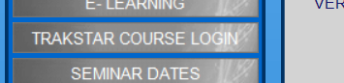
- Log in to the Mindflash system using your email address. You’ll be asked to create a password the first time you enter. If you have issues, we can create one for you. If you have previously accessed Mindflash to preview courses, then you’d have already created a password and must remember that. We have no access to any pw that you created. If you forgot just hit that link for the system to resend something to your email. The example shown here is me logging in using the email and pw I created as a “reporter”, not administrator.
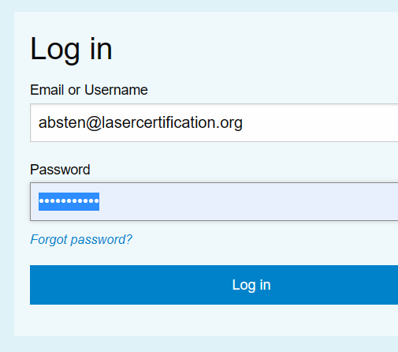
- That will bring you to the “Home” page of the administrative portion of the Mindflash program as shown below.
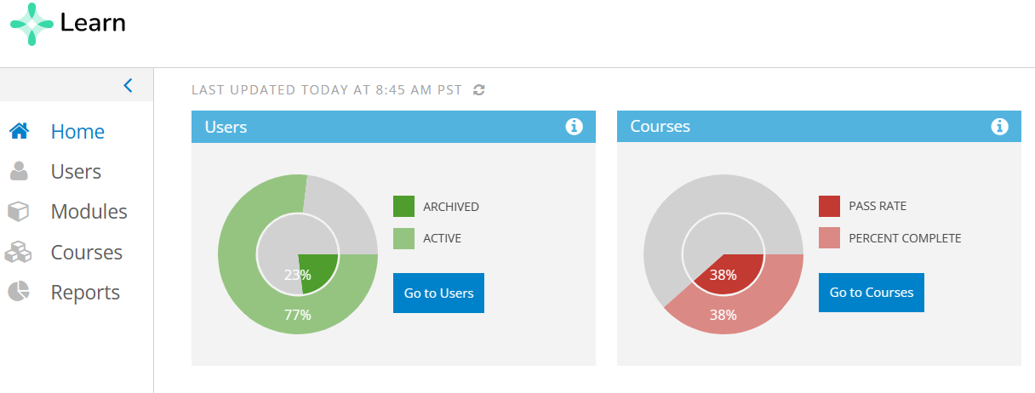
Your main choices are on the left. Home brings you back to what you see now. Users lets you go through the list in your own group. Modules shows you individual modules within the courses that your group is taking. Courses go to the overall course which includes all the modules within it, and Reports lets you run off reports on the courses or modules overall, or for the individual students.

So that we don’t make this tutorial too complicated, lets just focus for now on checking on the status of any particular student in a course, and also being able to download a PDF copy of their certificate after they’ve finished. There are different ways to get to command menus, but let’s just take the easy path for these two objectives.

- CHECK ON STATUS AND CERTIFICATE: From that “Home” page above, click on the “Courses” to the left (or click the blue box in the courses window on right). This next part looks confusing because it lists ALL the modules that are in any one course, and ALL courses. Ignore the modules and other courses. You must find your overall course. Here the branded course name is “Dermodality/Scalp Prodigy” so scroll down until you find the current version- not just a module.
When you click on “Courses” you’ll get a LONG LIST of courses to go through. Simplify it by using the search bar and typing in the name of your group. Here it’s “Dermodality” as shown in this screenshot:

NOTE: When you start searching or scrolling, you’ll see MANY courses. The only ones you have permission to see will be the “group” that we assign to you to view. If you click on any other courses or groups, you’ll get a “Don’t Have Permission” message, that you are not allowed to view that file. If you happen to get that when you try to view your own group just call us so we can fix it. “Reporters” such as yourself are all assigned to their own group.

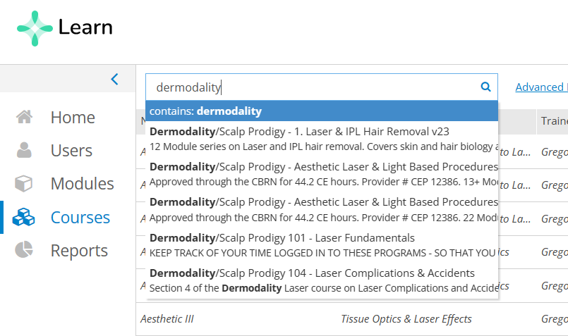
Here we’ve entered the phrase in the search field. Just hit the “Enter” key and the listings will be just those that involve Dermodality in some way as shown here:

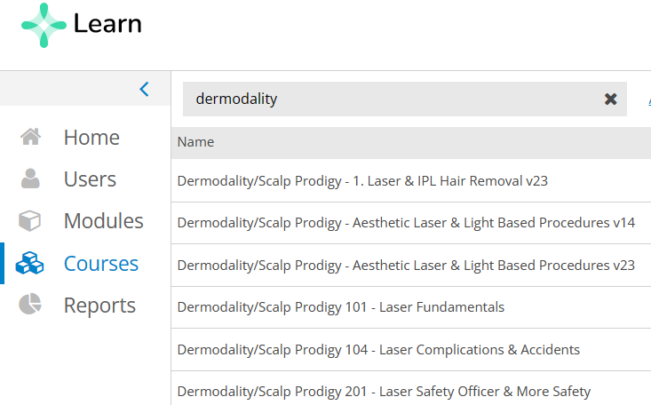
The “main” course to choose here for Aesthetics is the “Aesthetic Laser & Light Based Procedures v23. If you’re unsure of what your main course(s) is/are, then just contact Greg Absten.
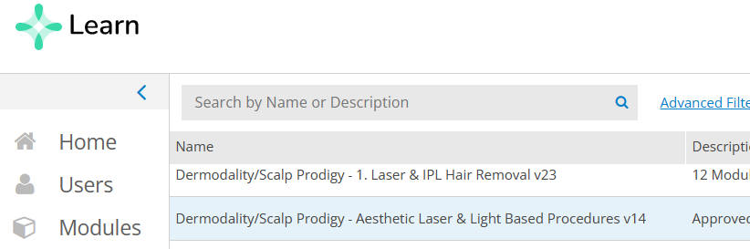
Using the search box is easier to find your own course(s), but you can also just scroll. Here I want the v14 course for Dermodality (a past course) so I click on that course and see the following:
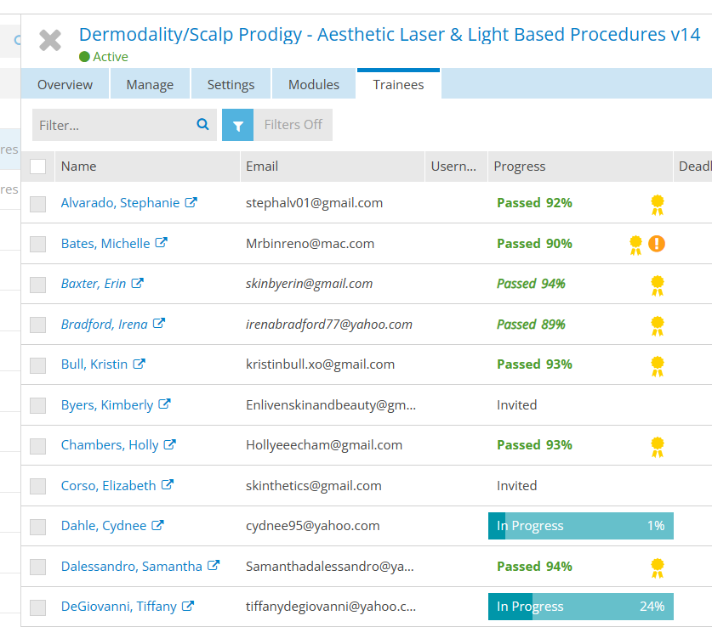
This will bring up BOTH their course status AND their certificate if they’ve finished. It also shows you their passing score on the quizzes. Click the yellow ribbon icon and you can download their certificate (and you can continue to do that even after they’re archived).

Now I want to see more detail about their progress in a course. I’ll choose Tiffany here at the bottom of the list who shows 24% complete on the course. Click on her name on the left and you’re taken to:
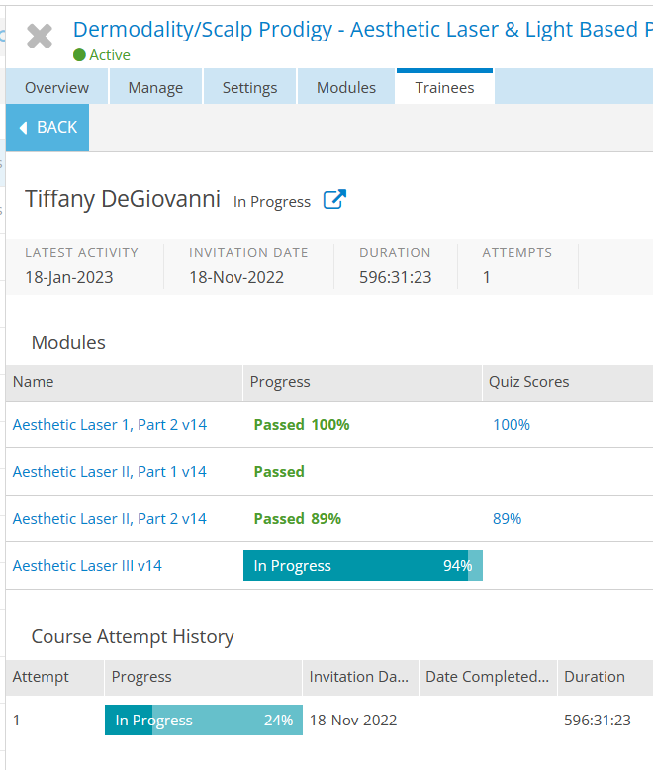
In that middle panel on Modules, I had to scroll down some to see where she currently is. You can see that she is in module III and 94% complete with that. If you keep scrolling down, you can see all the one’s they have yet to complete.

At the bottom in the Course Attempt History, you’ll see their progress overall in the entire course. This person is 94% complete with module III, but only 24% with the entire course. Importantly you’ll also see the “Duration” listed here. That is their total time in the course. It’s listed in a panel at the top, and down at the bottom. It’s listed in minutes so here at 24% complete they have spent 596 minutes, 31.23 seconds in the program, so about 9.93 hours so far and still have 76% more to go. You can take screen clips like I’ve done here to save this information as a file. (IMPORTANT – this time is NOT yet accurate and sometimes varies. You must WAIT until they finish a course, not just a module, in order to see the officially documented time, so check when they have completed a course. If they are enrolled in multiple “courses” as part of their overall training package, you can track their time as they go, when they finish each of the individual “courses”). Also note that it sometimes takes 24hrs after they finish a course for the information to update.
- EXPORTING GROUP DATA AS CSV OR EXCEL FILES:
When they have FINISHED the course, you’ll also be able to export their course time and scores from “REPORTS” tab you see in the “Home” screen. You can export reports on entire classes (courses) that include their individual times. These export as CSV or Excel files. There is also more overall information on your course on this page too.
From the “Home” page select “Reports” and then “Trainees” and you’ll see all the trainees from your course as shown below:
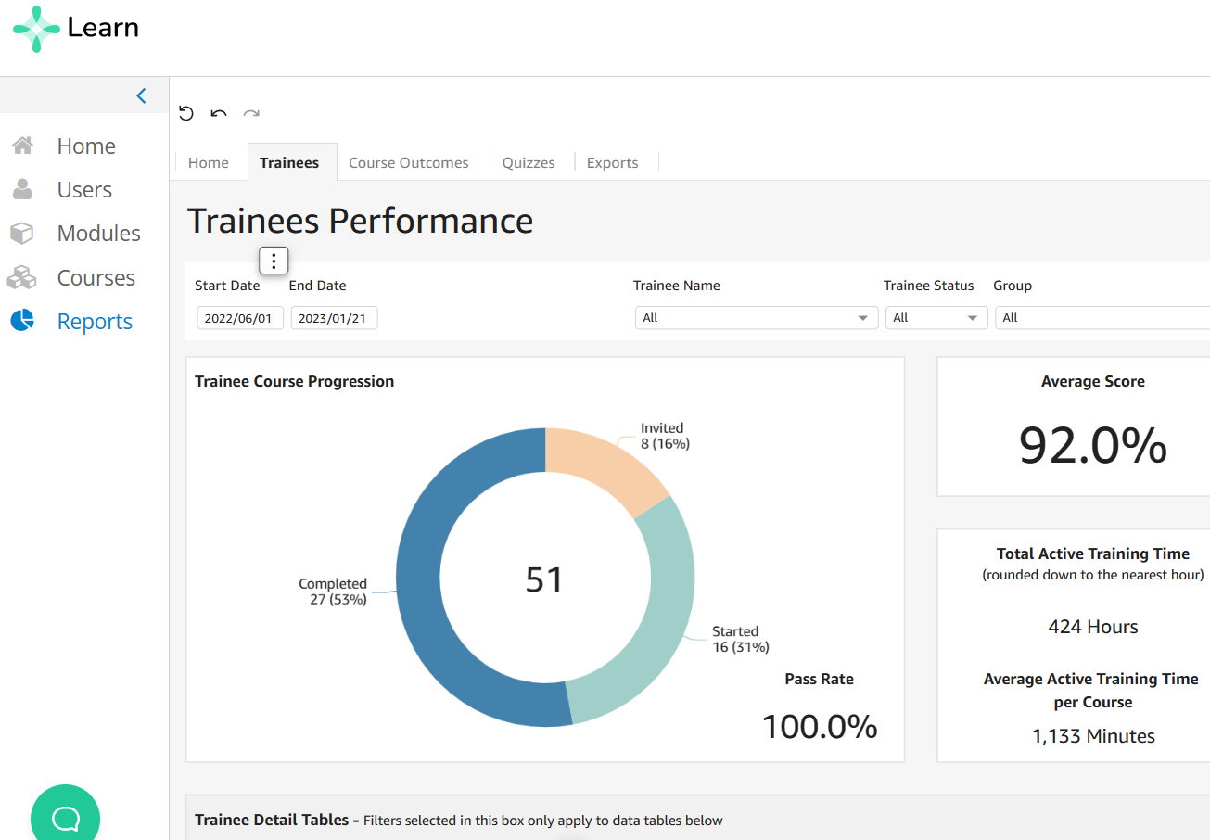
Here you see 51 people that have completed, started, or were invited but not yet started. Of those completing it the average score was 92.0%. It also shows the Average Active Training Time per course (this avg is what we base CBRN CE hours on). Toward the top left under the TRAINEES word there is a box for the date range. To ensure that you don’t cut people out of this I’d go back several months on the “start” date. A closeup of the date box is shown here:
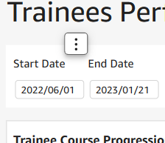
Scroll down and you’ll see the trainees box as shown:
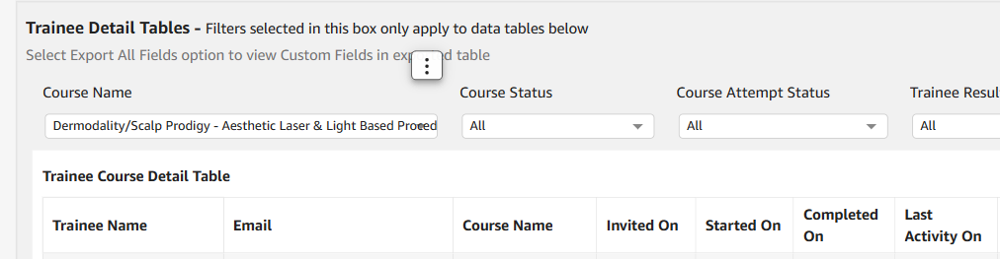
Under the “Course Name” field at left it’s important to select “just” your main active course.
There were several options here under the pull down, so I selected the Dermodality v14 from that list, as shown here:
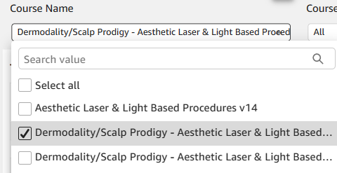
That brings up the entire list of students with their course status, final passing score, and the Active Training Time in Minutes in the last column to the right. It’s important to remember that IF the student was enrolled in different courses, that you’ll have to bring up EACH individually to show their cumulative Active Training Time.
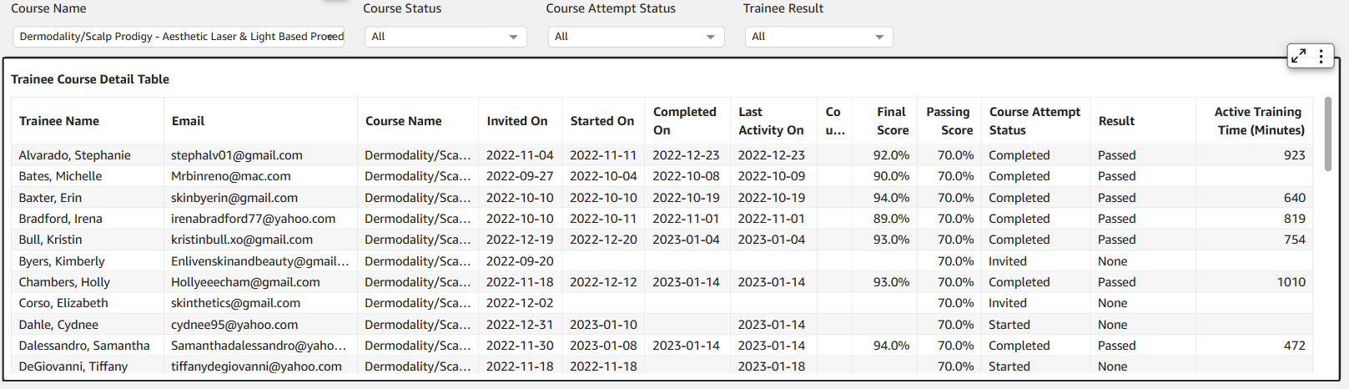
You can now export this list as a CSV or Excel file – note the small box in the top right of the table. The arrows expand this entire window to read it, but the three little dots have the menu to export as shown here:
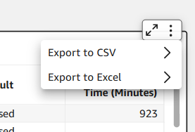
Here I choose to export it as Excel, and it asks me whether to export just visible fields or all fields as shown here:
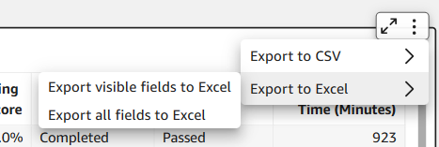
I find it better to export all fields initially, and then you can clean up your columns and rows to suit your own purposes.
You can explore other menu options as desired. Just log in to the system and explore at will in order to get used to the menu commands and reports.
As a “Reporter” (Mindflash’ s term – not ours) in the system you can view information from your assigned group. You cannot make any changes such as adding students to courses or even dropping them. You also cannot change specific information like the Time Duration (but neither can we as administrators).
Greg Absten
Cell 305.849.0285
absten@lasertraining.org

